WEEK-7:
step-by-step procedure for setting up an AWS Lambda function to trigger whenever an object is uploaded to an S3 bucket and update a DynamoDB table:

STEP-1: Create the S3 Bucket
-Search for S3 bucket in amazon console
-Click on the create bucket in the S3 bucket console
-Select general purpose
-Name the bucket as you needed
-Enable Versioning
-Click on the create bucket

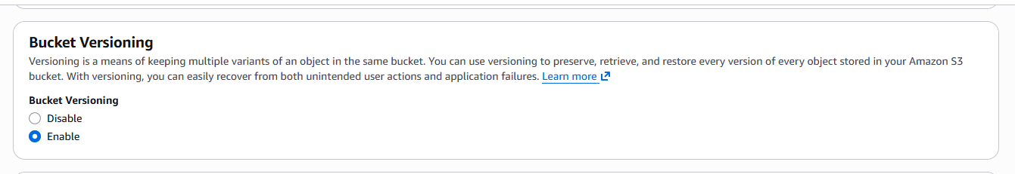

STEP-2: Create a AWS DynamoDB service table

-Search for dynamodb in the search bar of amazon console
-Click on the create table
-GIve any name to the table
Eg. newtable
-Name the row as unique with type string

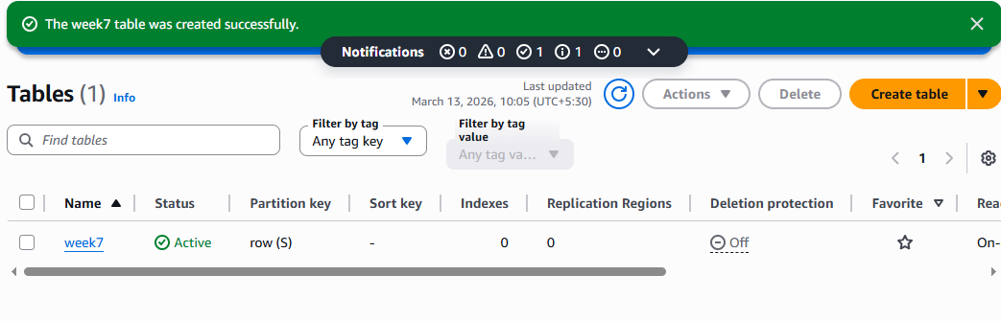

STEP-3: Creating the lambda function

-Search for aws lambda
-Click on the create function
-Choose Author from scratch
-Type any name in the function name input
-Choose a runtime
Eg.Python
-In permissions choose the role type
If available labrole in the existing roles
Or
Create a new role with basic lambda permissions
-click on the create function

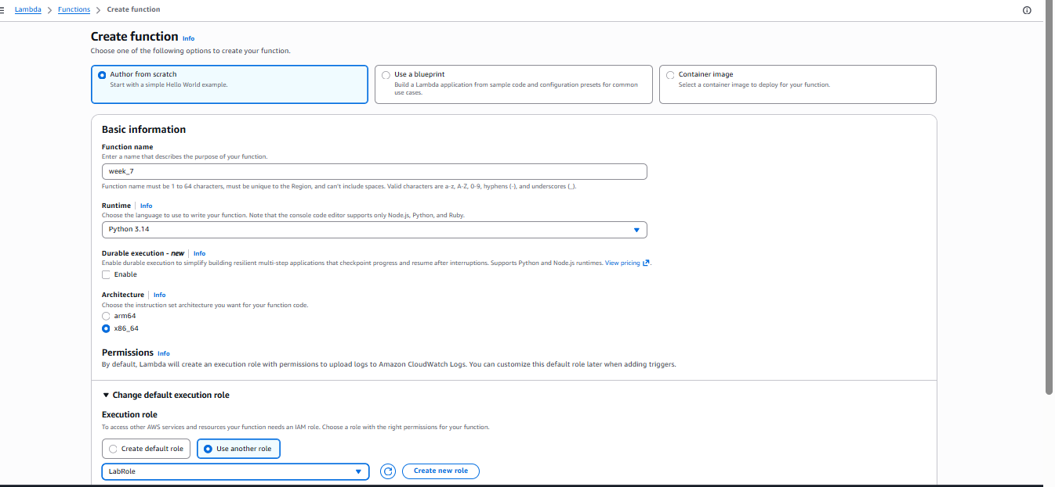

STEP-4: Adding trigger to connect the S3 bucket and DynamoDB

-Click on the Add trigger in the created function
-Search for S3 bucket in the trigger configuration
-Select the S3 bucket
-Choose the bucket which you want to apply the trigger
-Select All object create event in the event type, Acknoledge
-click on the add
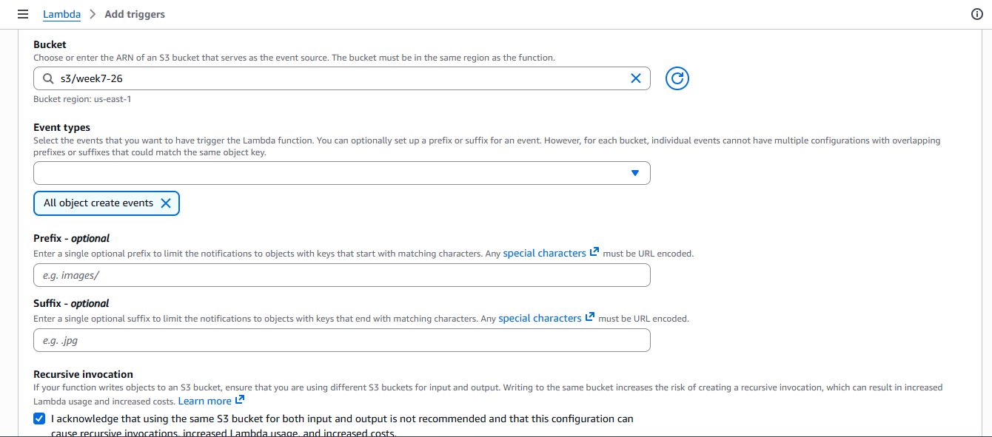

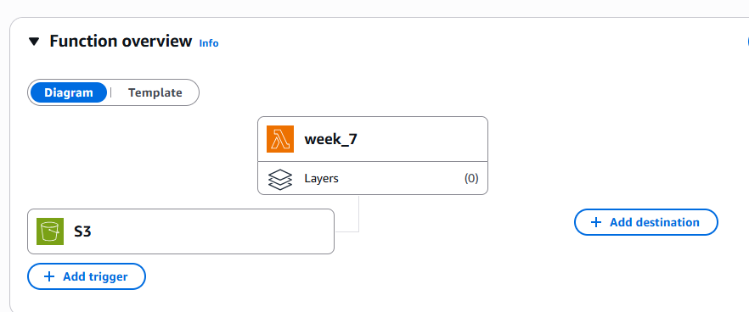

STEP: 5 Creating the deplyoment code and monitoring

-Add the code for triggering when object is uploaded
Eg
import boto3
from uuid import uuid4

def lambda_handler(event, context):

dynamodb = boto3.resource('dynamodb')
table = dynamodb.Table('Newtable')

if 'Records' in event:
for record in event['Records']:

bucket_name = record['s3']['bucket']['name']
object_key = record['s3']['object']['key']
size = record['s3']['object'].get('size', -1)
event_name = record.get('eventName', 'Unknown')
event_time = record.get('eventTime', 'Unknown')

table.put_item(
Item={
'private': str(uuid4()),
'Bucket': bucket_name,
'Object': object_key,
'Size': size,
'Event': event_name,
'EventTime': event_time
}
)

return {
'statusCode': 200,
'body': 'Data stored in DynamoDB'
}

Create a policy if you are getting the Iam role problem Otherwise skip this

-Search for IAM console in AWS console
-Go to roles
-Select the Lamda function name like you gave in the labmda creation

-In permission policies click on add permissions
-Select create inline policy

-Click on the JSON in the policy editor
Write this policy code in that editor

{
"Version": "2012-10-17",
"Statement": [
{
"Effect": "Allow", "Action": "dynamodb:PutItem",
"Resource": "arn:aws:dynamodb:us-west-2:669420739378:table/newtable"
}
]
}

-Click on the next
-Give any policy name
Eg.lambda-dynamo-policy
-Click on the create policy

STEP-6 : Upload any file(s) in the S3 bucket it will triggers and shows in both S3 bucket and the DynamoDB

-Click on the explore items in the DynamoDB
-click on the run
You’ll able to see the objects in the dynamodb which is uploaded in the S3 bucket
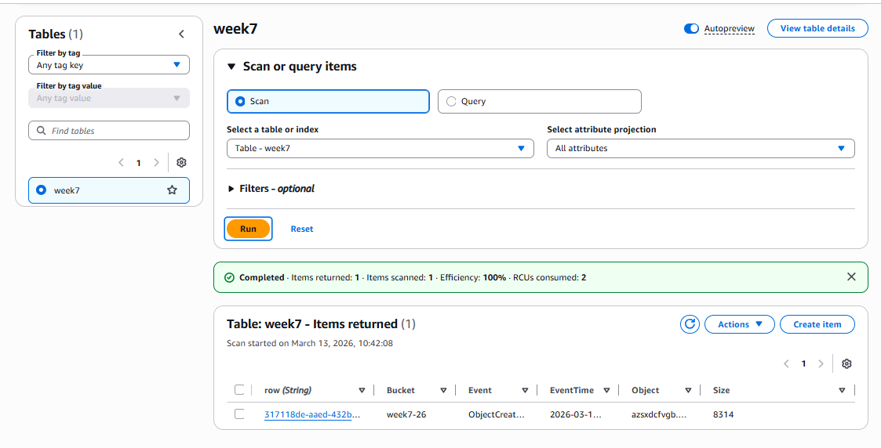

STEP-7: Monitoring using cloud watch

-Click on the Monitor tab in the lambda function
-Click on the view cloudwatch logs
-Click on the time lines and check the logs

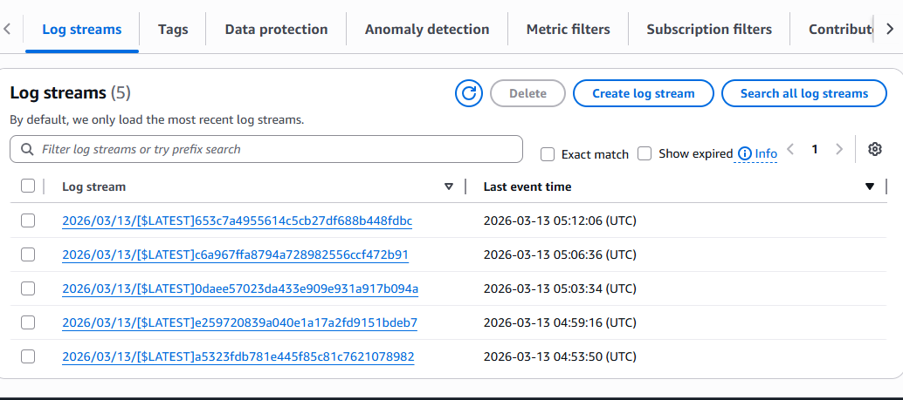

SBQ’s
- A company wants to automatically process images whenever they are uploaded to an S3 bucket. The system should resize the images and store them in another bucket. Which AWS service can be used to automatically run the code when the image is uploaded?
A: AWS Lambda triggered by Amazon S3 event notifications.

- A developer created a Lambda function to store uploaded file details into a DynamoDB table, but the function fails with a permission denied error when writing to the database. What could be the reason and how can it be fixed?
A: The AWS Lambda execution role lacks permission to write to Amazon DynamoDB, so add the required IAM policy.
- An application needs to run a piece of code every time a new file is uploaded to an S3 bucket to extract metadata and store it in a database. How would you design this using AWS Lambda?
A: Configure Amazon S3 upload events to trigger AWS Lambda which stores metadata in Amazon DynamoDB.

- A Lambda function is configured with an S3 trigger, but it is not executing when files are uploaded. What possible configuration issues might cause this problem?
A: Incorrect S3 event configuration, missing Lambda permissions, or wrong bucket notification settings.

- A company wants to process only .jpg image files uploaded to an S3 bucket using Lambda. How can the trigger be configured so that the function runs only for those files?
A: Configure the Amazon S3 trigger with a suffix filter .jpg for AWS Lambda.

- A Lambda function works correctly for a few uploads but fails when hundreds of files are uploaded simultaneously. What AWS feature helps Lambda handle large numbers of events?
A: AWS Lambda automatic scaling with concurrent executions.

- A developer wants to store the table name and bucket name separately from the code so that they can easily change them later. Which Lambda feature can be used to achieve this?
A: AWS Lambda environment variables.
- A Lambda function executes but does not show any output in the console, making debugging difficult. Which AWS service can be used to view logs and troubleshoot the issue?
A: Amazon CloudWatch logs.

- An organization wants a function to run every day at 10 PM to clean temporary files stored in S3. How can Lambda be triggered automatically at a scheduled time?
A: Use a scheduled rule in Amazon EventBridge to trigger AWS Lambda.

- A Lambda function processes uploaded files and stores metadata in DynamoDB, but duplicate records appear in the table when the same file is uploaded again. How can this issue be prevented?
A: Use a unique primary key or conditional writes in Amazon DynamoDB

- A Lambda function processes files uploaded to S3, but the processing sometimes takes more than 10 minutes. What limitation of Lambda must be considered here?
A: AWS Lambda has a maximum execution timeout of 15 minutes.

- A developer wants to allow a Lambda function to read files from S3 and write records into DynamoDB. What type of AWS security configuration must be created?
A: Create an AWS Identity and Access Management role with S3 read and DynamoDB write permissions.

- A company wants to automatically send a notification email whenever a file is uploaded to S3 using Lambda. Which AWS services can be integrated to achieve this?
A: Amazon S3 + AWS Lambda + Amazon Simple Notification Service.

- A Lambda function is triggered by S3 uploads, but the function keeps running multiple times for the same file. What could be the possible cause?
A: Multiple S3 event triggers or retry behavior causing repeated executions.

- An organization wants to build a fully serverless application where uploaded files are processed automatically without managing servers. Which AWS services can be combined with Lambda to achieve this architecture?
A: Amazon S3, AWS Lambda, Amazon DynamoDB, and Amazon API Gateway.

